16)I’d support the system with regular check-ups on the system,weekly schedule to look for bugs, necessary updates, newly added features that added from a monthly update.

First of all our website “Sirkelii.com”and it’s system has one of the best software systems and designs in the entire world.We are proud of that because our system has won “The Best Website of the Year” from the Awwwards in the last 3 years.

If anyone asks how our system has become like this it was a difficult thing to achieve it.....Our system had a lot of bugs and glitches for months when we first opened it in 2014 but then after we found our current I.T. guys and asked them for their help and they started to work on our system then they are started to shine.The new duo figured out some of the biggest bugs in the system and thanks to them we have see our mistake and changed them with our old “I.T.” guys.

Since then our website has updating it’s software monthly.

Then after these bugs disappeared we had another troubles;website speed,HTML errors,.....

Our speed was quite low after all these bugfixes because it couldn’t handled the process of the new updates.So,we started to check it every week instead of month and our geniuses fixed the speed trouble shortly after founding it.They have made some improvements in the system’s very own core and thus our speed has become quite fast.

We had HTML troubles due to some code problems but ey were easy fix to our masterminds.

After our bugs so started to decrease intensely, we started to look for the other websites to improve ourselves and the results was quite impressive we saw a lot of improvements.

We have developed a lot of new content we have to our new sections:”Our Resources, How to Run Analysis, Results,Our Company”.

Secondly our biggest chance was our website had a lot of costumers/users that searched us in the search engines but they had troubles due to our first name...After changing it to “Sirkelii.com” and a successful “Search Engine Optimization” our website was quite easy to find and it made our website one of the biggest reached websites for that year(2015).

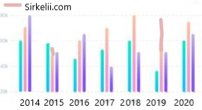

In 2017 our high numbered users/costumers had some trouble with the system’s design due to it was a little out of numbers so we have updated and improved our core design to this current version(below) and people started to use it more efficiently and easily.

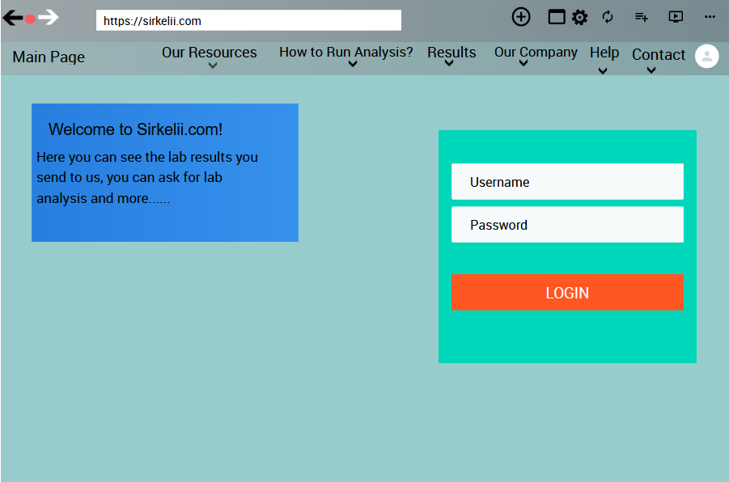

Finally after all the needs of our costumers/users we have made a few changes in the design and links to our system with the costumers/user’s suggestions, thanks to our brilliant I.T. duo and great costumers/users we have one of the greatest systems and we still improve it day by day thanks to these steps we learned.